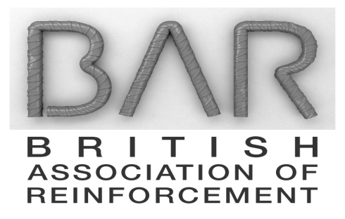

**BRITISH ASSOCIATION OF REINFORCEMENT**

**CONSTITUTION**

**(Revised December 2021)**

The name of the Association is the British Association of Reinforcement (BAR).

The Association is registered as a Company Limited by Guarantee (the Company) with its registered office at Gillingham House, 38-44 Gillingham Street, London SW1V 1HU.

**Aims and Objectives**

The Association is operated for the benefit of its members and for the benefit of the reinforced concrete sector of the UK construction industry.

BAR cannot dictate material sourcing. However, wherever possible, BAR and its members are expected to promote and support the UK reinforcement industry.

As the industry forum, BAR aims to:

* Promote and support the market share of reinforced concrete against competitive structural materials,
* To improve the overall quality of the product and service from the reinforcement industry via representation on relevant standard and specification committees and dialogue with UKAS accredited certification schemes,
* Improve the health and safety record of the UK reinforcement industry.
* Improve the environmental record of the UK reinforcement industry.
* Actively promote the UK reinforcement industry’s products and capabilities to relevant target audiences.
* Represent the UK reinforcement industry with HM Government, in Europe, stakekholders and with other key decision makers,
* Provide a forum in which common issues facing the UK reinforcement industry can be discussed and, if possible, resolved.

The above aims and objectives, and all associated discussions, are pursued in a non-commercial manner.

**Membership**

The Association has two grades of membership:

**Full Membership**

Full Membership of the Association is open to any company or other organisation that is actively manufacturing, fabricating or processing steel reinforcement in the UK, is accredited to a UKAS recognised certification scheme, will act to support of the reinforced concrete sector and can demonstrate the ability to support the aims and objectives of the Association as set out in the Constitution. Full Membership is subject to BAR Chairman approval subject to Membership consensus.

Only Full Members are entitled to attend BAR Members meetings and to vote on key issues such as membership entitlement, subscription setting etc. Similarly, only representatives of Full Members may represent BAR on outside bodies such as British Standards committees and other stakeholder groups.

**Associate Membership**

Associate Membership of the Association is open to individuals and organisations that have an interest in and wish to support and promote the reinforcement sector of the UK construction industry, but do not meet the criteria set out above for Full Member status. Associate Membership is subject to BAR membership approval.

Associate member status should be open to those that are not eligible to be a Full Member of BAR as defined in the Constitution. Associate membership is open to all non-UK manufacturers subject to the discretion and agreement of the BAR membership.

This membership category is split into three sub categories:

* Contractors, clients and specifiers
* Suppliers, including coupler manufacturers and other component suppliers
* Other bodies such as Accreditation bodies, standards bodies, engineering institutions, test houses and academic institutions.

Associate Members are entitled to attend BAR working committee meetings (currently the Technical Committee and Health & Safety Committee) and BAR events and to receive BAR communications and other information.

Overseas manufacturers and importers of products that compete with those of Full Members of the Association are not eligible for Associate Member status.

**Governance**

The affairs of the Association are governed by the Members Meeting of Full Members that will meet at least four times per year. Every Full Member of the Association is entitled to send a representative to the Meeting.

Decisions reached by the Members Meeting will be by consent, but in the event of a vote, each Full Member is entitled to register one vote only on matters raised at meetings irrespective of the size of the organisation they represent. In the event of a tie on any vote, the Chairman is entitled to a casting vote.

BAR Members will elect a Chairman, who will preside over its affairs and, if appropriate, represent the Association publicly. The normal term of office for the Chairman is a maximum of two years but this can be extended by Member consensus.

The operations and marketing of BAR are managed by the contracted Project Director and via the Association’s affiliation to the Mineral Products Association. The Project Director reports to the Chairman.

The Members shall nominate a minimum of three of its members representatives, one of whom will be the Chairman, to act as Directors of the Company to discharge on behalf of the Association, the statutory and other requirements of the Company. Company Secretariat is provided by MPA.

BAR Members may, from time to time, nominate a representative of BAR to outside bodies such as British Standards Committees. Such nominees may only be made from Full Members of the Association unless specifically determined by a majority of Members.

Associate members may attend Association sub committees, working parties and seminars.

In the event of any conflict of interest arising between Associate and Full members, these should be identified on a case-by-case basis by the Chairman and resolved appropriately by, for example, excluding any Associate Members from the relevant agenda items.

Public statements from the Association must be approved by the Chairman following Full Members’ input and consensus before circulation.

**Subscriptions**

The Members Meeting will determine an annual subscription for Full Members and Associate Members to provide finance to cover the Association’s operating expenses and achieve the aims and objectives set out above. Subscriptions are invoiced and collected by MPA.

Additionally, the Members Meeting may, if necessary, raise a special levy to fund any special project or exercise that would further the activities of the Association.

Members and Associate Members may terminate their membership of the Association by giving three months written notice to the Chairman. Subscription fees are non-refundable.

**---ooo---**